Ramses

AF_logo_RGB_15x15.tifUser Manual

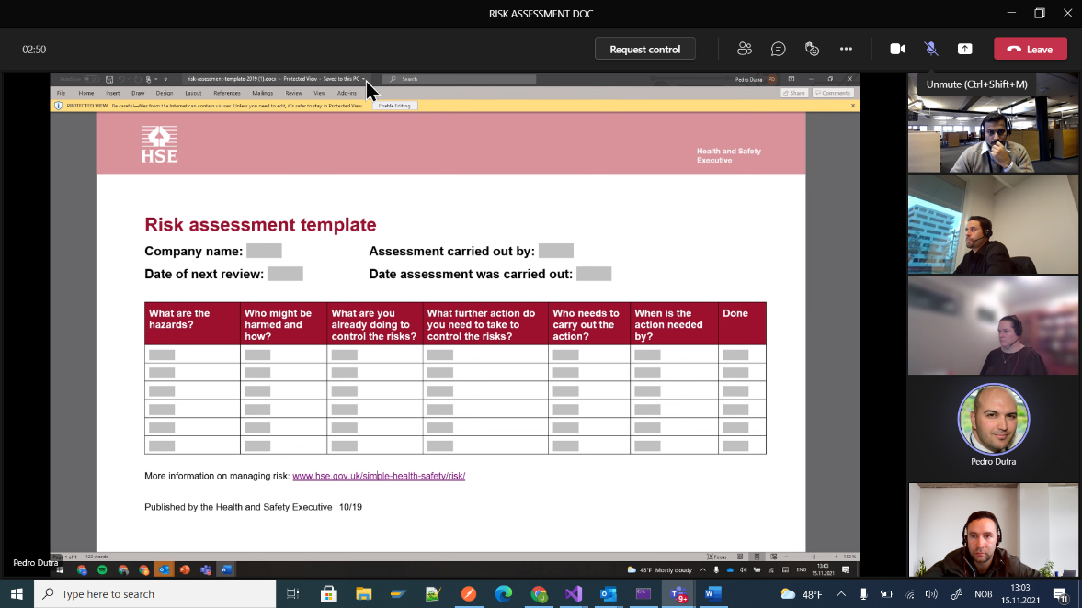



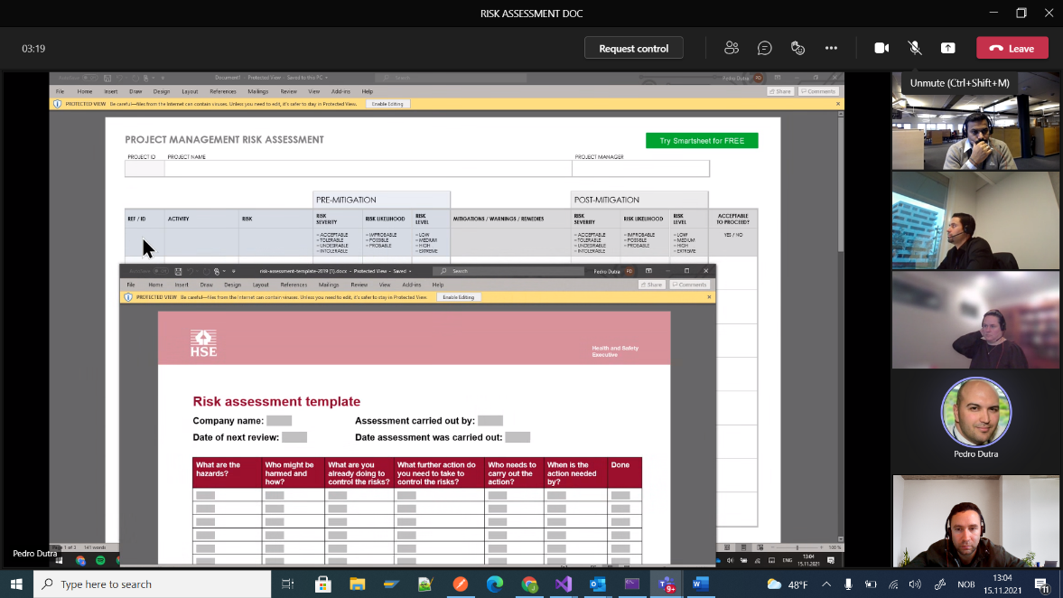

[1 Introduction 4](#_Toc428866134)

[2 Ramses Portal 4](#_Toc428866135)

[2.1 Introduction 4](#_Toc428866136)

[2.2 General 4](#_Toc428866137)

[3 View/Create/Modify Order App 9](#_Toc428866138)

[3.1 Introduction 9](#_Toc428866139)

[3.2 General 9](#_Toc428866140)

[3.3 Blend Orders 21](#_Toc428866141)

[3.4 Process Orders 39](#_Toc428866142)

[3.5 Transfer Orders 54](#_Toc428866143)

[3.6 Import Order 65](#_Toc428866144)

[3.7 Order Template 67](#_Toc428866145)

[3.8 Duplicate Order 69](#_Toc428866146)

[3.9 Export order Reports 70](#_Toc428866147)

[3.10 Delete Order 70](#_Toc428866148)

[3.11 ERP Adjustment 70](#_Toc428866149)

[4 View/Create Operator Comments App 72](#_Toc428866150)

[4.1 Introduction 72](#_Toc428866151)

[4.2 General 72](#_Toc428866152)

[4.3 Operating Instructions 80](#_Toc428866153)

[4.4 Operator Log 86](#_Toc428866154)

[5 Reports App 90](#_Toc428866155)

[5.1 Introduction 90](#_Toc428866156)

[5.2 General 90](#_Toc428866157)

[5.3 Daily Instruction Reports 92](#_Toc428866158)

[5.4 Shift Reports 95](#_Toc428866159)

[5.5 Handover Reports 97](#_Toc428866160)

[6 PPL Instructions App 98](#_Toc428866161)

[6.1 Introduction 98](#_Toc428866162)

[6.2 General 98](#_Toc428866163)

[6.3 Export to .PDF 99](#_Toc428866164)

[7 Tank Monitoring App 99](#_Toc428866165)

[7.1 Introduction 99](#_Toc428866166)

[7.2 General 99](#_Toc428866167)

[7.3 Tanks 102](#_Toc428866168)

[7.4 Tank Information 103](#_Toc428866169)

[8 Inventory Report App 109](#_Toc428866170)

[8.1 Introduction 109](#_Toc428866171)

[8.2 General 109](#_Toc428866172)

[8.3 Export to .PDF 110](#_Toc428866173)

[9 Lineup 110](#_Toc428866174)

[9.1 Introduction 110](#_Toc428866175)

[9.2 General 110](#_Toc428866176)

[9.3 Add a Lineup 110](#_Toc428866177)

[9.4 Edit a Lineup 113](#_Toc428866178)

[9.5 Delete a Lineup 114](#_Toc428866179)

[10 Asset Profile 114](#_Toc428866180)

[10.1 Introduction 114](#_Toc428866181)

[10.2 General 114](#_Toc428866182)

[10.3 Blender 115](#_Toc428866183)

[10.4 Line 117](#_Toc428866184)

[10.5 Pump 118](#_Toc428866185)

[10.6 Blend Stream 119](#_Toc428866186)

[10.7 Additive Stream 121](#_Toc428866187)

[10.8 Storage 124](#_Toc428866188)

[10.9 Stream 127](#_Toc428866189)

[10.10 Additive Feed/Yield Stream 129](#_Toc428866190)

[10.11 Process Unit 130](#_Toc428866191)

[10.12 Scheduling Area 132](#_Toc428866192)

[10.13 Import 133](#_Toc428866193)

[11 Material Manager 137](#_Toc428866194)

[11.1 Introduction 137](#_Toc428866195)

[11.2 General 137](#_Toc428866196)

[11.3 Material Group 138](#_Toc428866197)

[11.4 Material 139](#_Toc428866198)

[11.5 Add 140](#_Toc428866199)

[11.6 Sport Import 140](#_Toc428866200)

[11.7 Manual Import 140](#_Toc428866201)

[12 User Settings 141](#_Toc428866202)

[12.1 General 141](#_Toc428866203)

[13 Asset Security 142](#_Toc428866204)

[13.1 Introduction 142](#_Toc428866205)

[13.2 General 142](#_Toc428866206)

[13.3 Add/Edit 143](#_Toc428866207)

[13.4 Bulk Add 145](#_Toc428866208)

[13.5 Search 145](#_Toc428866209)

[14 User Specification 146](#_Toc428866210)

[14.1 Introduction 146](#_Toc428866211)

[14.2 General 147](#_Toc428866212)

[14.3 Configuration 149](#_Toc428866213)

[14.4 Indexes Configuration 154](#_Toc428866214)

[14.5 Data 156](#_Toc428866215)

[14.6 Export 158](#_Toc428866216)

[14.7 Important User Specifications 159](#_Toc428866217)

[15 Event Editor – Template Wizard 167](#_Toc428866218)

[15.1 Introduction 167](#_Toc428866219)

[15.2 General 167](#_Toc428866220)

[15.3 Template 168](#_Toc428866221)

[15.4 Settings 169](#_Toc428866222)

[15.5 Actions 181](#_Toc428866223)

[15.6 Security 184](#_Toc428866224)

[16 Process Library 186](#_Toc428866225)

[16.1 Introduction 186](#_Toc428866226)

[16.2 General 186](#_Toc428866227)

[16.3 Summary 187](#_Toc428866228)

[16.4 Schedule 188](#_Toc428866229)

[16.5 Trigger 190](#_Toc428866230)

[16.6 Topic 193](#_Toc428866231)

[16.7 Actions 195](#_Toc428866232)

[16.8 Export 207](#_Toc428866233)

[17 Shift Report – Template Wizard 208](#_Toc428866234)

[17.1 Introduction 208](#_Toc428866235)

[17.2 General 208](#_Toc428866236)

[17.3 Basic Settings 209](#_Toc428866237)

[17.4 Sections 209](#_Toc428866238)

[17.5 Section Configuration 209](#_Toc428866239)

[17.6 Section Tags 209](#_Toc428866240)

[17.7 Import/Export Shift Report Template 210](#_Toc428866241)

[18 Audit Viewer 211](#_Toc428866242)

[18.1 Introduction 211](#_Toc428866243)

[18.2 General 212](#_Toc428866244)

[18.3 Asset Filter 212](#_Toc428866245)

[18.4 Event Filter 212](#_Toc428866246)

[18.5 Audit Trail 213](#_Toc428866247)

[18.6 Integration with Event Editor 213](#_Toc428866248)

[19 Oil Accounting Reports 214](#_Toc428866249)

[19.1 Introduction 214](#_Toc428866250)

[19.2 General 215](#_Toc428866251)

[19.3 Area Report 215](#_Toc428866252)

[19.4 Crude Tank Composition Report 217](#_Toc428866253)

[19.5 Monthly Mass Balance Report 218](#_Toc428866254)

[19.6 Monthly Sales and Receipt by Cargo Report 219](#_Toc428866255)

[19.7 Truck Loading Report 220](#_Toc428866256)

[19.8 Tank Inventory Report 221](#_Toc428866257)

[20 Material Composition 222](#_Toc428866258)

[20.1 Introduction 222](#_Toc428866259)

[20.2 General 222](#_Toc428866260)

[20.3 Crude Disc 223](#_Toc428866261)

Ramses User Manual

# Introduction

This is the user manual for the Ramses system, it describes all you need to know to be able to use the functionalities that the Ramses system supplies.

# Ramses Portal

## Introduction

The Ramses portal is the shell for the entire Ramses solution. It handles all of the navigation between apps and modules.

## General

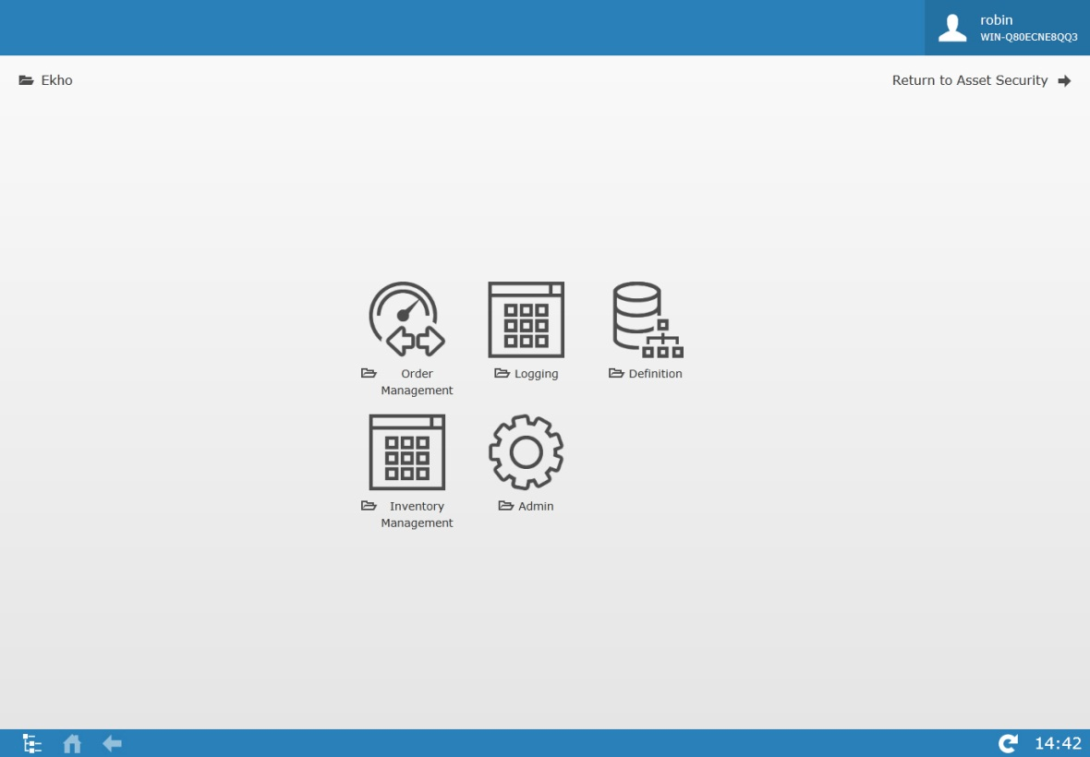

|  |  |
| --- | --- |
| **Icon** | **Description** |
|  | Shows the logged in User, reads from the active directory. |
|  | Displays where you are at in the portal and how you got there. |
|  | Click to return once the back or home button has been used. |
|  | Opens the navigation treeview |
|  | Click to get to the root level of the startpage. |
|  | Click to go back one level. |
|  | If Green, indication that Ekho has established a connection to IP21. |
|  | Click to refresh the system. |
|  | When this icon is visible, it is possible to bring up a manual describing the functionality of the current screen. |
|  | Displays current time. |

### Navigation

When first entering the portal, all of the modules available to you will be shown, by clicking on a module, all of the apps that the chosen module holds will be displayed instead.

### Treeview Navigation

The treeview navigation is especially useful when wanting to navigate away from one app to another without having to go back to the start page.

Clicking  will open up the treeviewer.

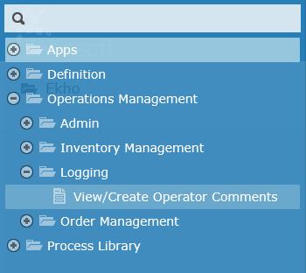

To navigate to an app from here, simply click on the app in the treeview.

The search field can be used to quickly find an app, simply start writing the name of the app and the treeviewer will automatically narrow the list down to only the apps that match your search.

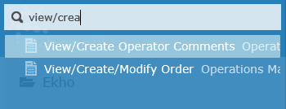

### Modules

There are five modules in Ramses. Note that all of these modules might not be available for all users.

|  |  |
| --- | --- |
| **Icon** | **Description** |
|  | The Order Management module holds the View/Create/Modify Orders app. |
|  | The Logging module holds the View/Create Operator Comments app and Reports app. |
|  | The Inventory Management module holds the Tank Monitoring app and the Crude Composition Tracking App. |
|  | The Admin module holds the Lineup Manager app, Asset Profile app, Material Manager app, User Settings app, Shift Report – Template Wizard app and the Event Editor – Template app. |
|  | The System Management module holds the Asset Security app, Audit Viewer app, Process Library app, KPI Manager app and the User Specification app. |

#### Order Management

There is one app in the Order Management Module.

|  |  |
| --- | --- |
| **Icon** | **Description** |
|  | The View/Create/Modify Order facilitates the creation, editing and viewing of orders (Process, Transfer, Blend and Operating Instructions). This app contains multiple functions such as order import, order templates, order duplication and more. |

#### Logging

There are three apps in the Logging Module, note that all of these apps might not be available for all users.

|  |  |
| --- | --- |
| **Icon** | **Description** |
|  | The view/create operator comments app allows you to view/edit and add operating instructions and logs. |
|  | The reports app allows you to view, publish and sign-off on daily instruction reports, shift reports and handover reports. |
|  | The PPL Instructions App lists all of the “Active” Operating Instructions that are owned by “Planning” as well as any Order Comments that has been categorized with a category configured to be a part of the PPL Instructions App. |

#### Inventory Management

There are four apps in the Inventory Management Module.

|  |  |
| --- | --- |
| **Icon** | **Description** |
|  | The Tank Monitoring app gives you an overview of the status of all the tanks related to your security group. |
|  | The Crude Tank Composition app is a tool where the current tank composition can be viewed for all storage assets that has enabled crude composition tracking. It is also possible in this app to override the crude composition. |
|  | The Inventory Report app lets you view past or present data related to the storage assets and export it as a report. |
|  | The Oil Accounting Reports app contains various reports for Mass Balance, Sales and Receipts, Tank Inventory etc that can be viewed in the system and exported to excel. |

#### Admin

There are six apps in the Admin Module, note that all of these apps might not be available for all users.

|  |  |
| --- | --- |
| **Icon** | **Description** |
|  | The asset profile allows you to view/maintain blenders, lines, pumps, storages and streams. |
|  | The Event Editor – Template Wizard is a tool that allows for the addition, edition and deletion of templates that will be used within the event editor application as pages. This tool contains multiple sections such as basic setting, advanced setting, default values and security. |
|  | The Lineup app allows you to create and maintain lineups in the system used to define the route between source and destination assets. |
|  | The Material Manager lets you manage the materials in the system and gives you functions to view/edit and add materials. |
|  | The Shift Report – Template Wizard app allows you to Import/Export templates of the production data part of the shift reports, per area/subarea. |
|  | The user Settings application allows the users to select the default comment category that should be pre-selected for them whenever they are adding a comment to an event (Order, Log, Instruction) |

#### System Management

There are four apps in the System Management Module, note that all of these apps might not be available for all users.

|  |  |
| --- | --- |
| **Icon** | **Description** |
|  | The Asset Security app lets you manage user groups and asset security for said groups. |
|  | The User Specifications app allows you to configure specifications that can be used when there is a need to store reference information that is not stored by default in the system. |
|  | The Process Library app is a management and communication system that allows you to set up schedule/trigger/topic related jobs that the system will carry out. |
|  | The purpose of the Audit Viewer app is to allow you to see how attributes on events in the system has been modified over time. |

# View/Create/Modify Order App

## Introduction

The View/Create/Modify Order facilitates the creation, editing and viewing of orders (Process, Transfer, Blend and Operating Instructions). This app contains multiple functions such as order import, order templates, order duplication and more.

## General

When first accessing the View/Create/Modify Order app, the page may appear blank. This is because no initial page has been defined.

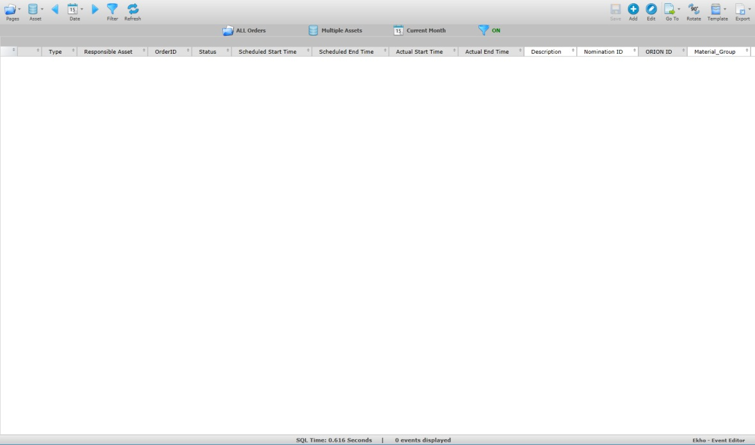

|  |  |
| --- | --- |
| **Icon** | **Description** |
|  | Click to switch between the various pages. |
|  | Click to hide or display the assets pane where the assets can be filtered on. |
|  | Click to select a date for the order search. The arrow on each side allows you to change the date incrementally. |
|  | Click to open the advanced filter. |
|  | Click to refresh the date or to apply new settings. |
|  | Click to save after editing values in the order grid. |
|  | Click to add an order. |
|  | Click to edit selected order. |
|  | Click to switch the event editor grid for a Gantt chart. |
|  | Click to navigate between pre-configured order related pages (e.g. Import Order, Duplicate Order) |
|  | Click to traverse the order view, either by column or by row. |
|  | Click to save your filtered display as a template or to load a template. |
|  | Click to export the order data to either Excel or PDF. |
|  | Clicking this button will bring up a menu with all columns in the event editor grid where you can see what column filters are applied or apply new column filters. |
|  | When the Gantt chart is being viewed, this button can be pressed to bring up an information menu for the selected order. |

The sub header row beneath the toolbar is designed to display the event filtering selections.







|  |  |
| --- | --- |
| **Icon** | **Description** |
| EEPagesNumberIcon.png | Displays the name of the page that is selected. |
| EEAssetsMultiIcon.png | Displays the asset that has been selected, if more than one asset is selected, “Multiple Assets” will be displayed. |
| EELastEventIcon.png | Displays the date selected (relative or specific). |
| EEFilterApplyIcon.png | Displays whether an advanced filter is “ON” or “OFF”. Click the icon to toggle between them if an advanced filter has been set. If no filter option is selected the icon will displayed with “NONE” beside. |

### Pages

Click on 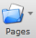 to select an order page.

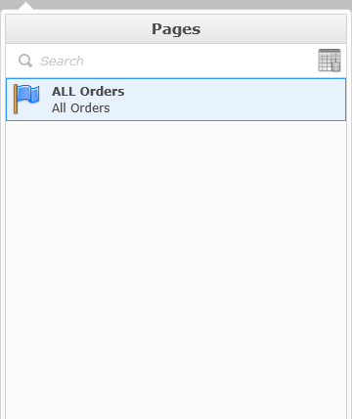

Pages displays a list of all available order pages, a page is an event template created from the “Event Editor – Template Wizard” app. Each page will have a different color flag associated with it to signify a different type of page.

Hover your mouse on the page name and you will see small icons to the right of the name.

Click  to flag the page into your favorites. Your favorites will be displayed on the top of the list. The next time you open the panel and hover your mouse on the name of the page the icon will look like this .

You have the option to set a page as the default page to open when navigating to the view/create/modify orders app.

While hovering your mouse over the page name, a check mark icon appears. By default the check icon  is gray, signifying that the page is not the default, clicking on this icon will change its appearance to  indicating that it is now the default page.

### Assets

Click on 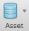 to select the assets you would like to view corresponding orders with.

One or more assets can be selected from the list. The number of assets selected will be shown in parentheses.

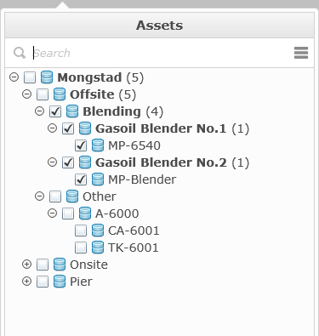

If you know the name of the asset that you are looking for, you can use the search option. Once the keyword that you want to search for is completely typed, hit the enter key, if the name can be found in the asset list it will be highlighted. If you type only a partial name, the list will be open on the first possible match but the name will then be highlighted.

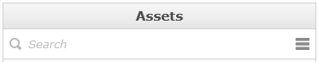

If you need to select or unselect the entire list of items, you can use a quick tool, click on the icon and select the option to select or clear the items.

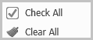

Right click on an Asset in the tree-view to check or un-check all the descendants of the asset.

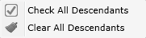

### Date

Click on 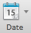 to select/apply a date selection

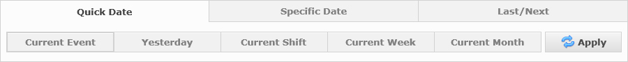

Three date types are available: Quick Date, Specific Date and Last/Next.

#### Quick Date

“Quick Date” has a combination of relative and status based searches that are predefined.



**Current Event**: Displays only open events (events with expected/actual (actual overrides expected) start time that is lesser than now and with no actual end time).

**Yesterday**: Displays yesterday’s open events between 00:00:00 and 23:59:59 (based on the current date), meaning any event whose start time (expected/actual, actual overrides expected) was either before or during the period as long as end time (expected/actual, actual overrides expected) also is during or after that period or not set yet are shown.

**Current Shift**: Displays all events for the current shift, works the same way as Yesterday with respect of timestamps used.

**Current Week**: Displays events between the last Sunday from 00:00:00 to current day, works the same way as Yesterday with respect of timestamps used.

**Current Month**: Displays events between the first day of the month from 00:00:00 to current day, works the same way as Yesterday with respect of timestamps used

#### Specific Date

“Specific Date” allows you to select a specific start date and end date.

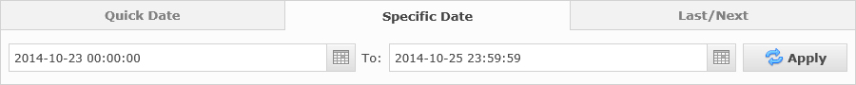

Ramses

AF_logo_RGB_15x15.tifUser Manual



[1 Introduction 4](#_Toc428866134)

[2 Ramses Portal 4](#_Toc428866135)

[2.1 Introduction 4](#_Toc428866136)

[2.2 General 4](#_Toc428866137)

[3 View/Create/Modify Order App 9](#_Toc428866138)

[3.1 Introduction 9](#_Toc428866139)

[3.2 General 9](#_Toc428866140)

[3.3 Blend Orders 21](#_Toc428866141)

[3.4 Process Orders 39](#_Toc428866142)

[3.5 Transfer Orders 54](#_Toc428866143)

[3.6 Import Order 65](#_Toc428866144)

[3.7 Order Template 67](#_Toc428866145)

[3.8 Duplicate Order 69](#_Toc428866146)

[3.9 Export order Reports 70](#_Toc428866147)

[3.10 Delete Order 70](#_Toc428866148)

[3.11 ERP Adjustment 70](#_Toc428866149)

[4 View/Create Operator Comments App 72](#_Toc428866150)

[4.1 Introduction 72](#_Toc428866151)

[4.2 General 72](#_Toc428866152)

[4.3 Operating Instructions 80](#_Toc428866153)

[4.4 Operator Log 86](#_Toc428866154)

[5 Reports App 90](#_Toc428866155)

[5.1 Introduction 90](#_Toc428866156)

[5.2 General 90](#_Toc428866157)

[5.3 Daily Instruction Reports 92](#_Toc428866158)

[5.4 Shift Reports 95](#_Toc428866159)

[5.5 Handover Reports 97](#_Toc428866160)

[6 PPL Instructions App 98](#_Toc428866161)

[6.1 Introduction 98](#_Toc428866162)

[6.2 General 98](#_Toc428866163)

[6.3 Export to .PDF 99](#_Toc428866164)

[7 Tank Monitoring App 99](#_Toc428866165)

[7.1 Introduction 99](#_Toc428866166)

[7.2 General 99](#_Toc428866167)

[7.3 Tanks 102](#_Toc428866168)

[7.4 Tank Information 103](#_Toc428866169)

[8 Inventory Report App 109](#_Toc428866170)

[8.1 Introduction 109](#_Toc428866171)

[8.2 General 109](#_Toc428866172)

[8.3 Export to .PDF 110](#_Toc428866173)

[9 Lineup 110](#_Toc428866174)

[9.1 Introduction 110](#_Toc428866175)

[9.2 General 110](#_Toc428866176)

[9.3 Add a Lineup 110](#_Toc428866177)

[9.4 Edit a Lineup 113](#_Toc428866178)

[9.5 Delete a Lineup 114](#_Toc428866179)

[10 Asset Profile 114](#_Toc428866180)

[10.1 Introduction 114](#_Toc428866181)

[10.2 General 114](#_Toc428866182)

[10.3 Blender 115](#_Toc428866183)

[10.4 Line 117](#_Toc428866184)

[10.5 Pump 118](#_Toc428866185)

[10.6 Blend Stream 119](#_Toc428866186)

[10.7 Additive Stream 121](#_Toc428866187)

[10.8 Storage 124](#_Toc428866188)

[10.9 Stream 127](#_Toc428866189)

[10.10 Additive Feed/Yield Stream 129](#_Toc428866190)

[10.11 Process Unit 130](#_Toc428866191)

[10.12 Scheduling Area 132](#_Toc428866192)

[10.13 Import 133](#_Toc428866193)

[11 Material Manager 137](#_Toc428866194)

[11.1 Introduction 137](#_Toc428866195)

[11.2 General 137](#_Toc428866196)

[11.3 Material Group 138](#_Toc428866197)

[11.4 Material 139](#_Toc428866198)

[11.5 Add 140](#_Toc428866199)

[11.6 Sport Import 140](#_Toc428866200)

[11.7 Manual Import 140](#_Toc428866201)

[12 User Settings 141](#_Toc428866202)

[12.1 General 141](#_Toc428866203)

[13 Asset Security 142](#_Toc428866204)

[13.1 Introduction 142](#_Toc428866205)

[13.2 General 142](#_Toc428866206)

[13.3 Add/Edit 143](#_Toc428866207)

[13.4 Bulk Add 145](#_Toc428866208)

[13.5 Search 145](#_Toc428866209)

[14 User Specification 146](#_Toc428866210)

[14.1 Introduction 146](#_Toc428866211)

[14.2 General 147](#_Toc428866212)

[14.3 Configuration 149](#_Toc428866213)

[14.4 Indexes Configuration 154](#_Toc428866214)

[14.5 Data 156](#_Toc428866215)

[14.6 Export 158](#_Toc428866216)

[14.7 Important User Specifications 159](#_Toc428866217)

[15 Event Editor – Template Wizard 167](#_Toc428866218)

[15.1 Introduction 167](#_Toc428866219)

[15.2 General 167](#_Toc428866220)

[15.3 Template 168](#_Toc428866221)

[15.4 Settings 169](#_Toc428866222)

[15.5 Actions 181](#_Toc428866223)

[15.6 Security 184](#_Toc428866224)

[16 Process Library 186](#_Toc428866225)

[16.1 Introduction 186](#_Toc428866226)

[16.2 General 186](#_Toc428866227)

[16.3 Summary 187](#_Toc428866228)

[16.4 Schedule 188](#_Toc428866229)

[16.5 Trigger 190](#_Toc428866230)

[16.6 Topic 193](#_Toc428866231)

[16.7 Actions 195](#_Toc428866232)

[16.8 Export 207](#_Toc428866233)

[17 Shift Report – Template Wizard 208](#_Toc428866234)

[17.1 Introduction 208](#_Toc428866235)

[17.2 General 208](#_Toc428866236)

[17.3 Basic Settings 209](#_Toc428866237)

[17.4 Sections 209](#_Toc428866238)

[17.5 Section Configuration 209](#_Toc428866239)

[17.6 Section Tags 209](#_Toc428866240)

[17.7 Import/Export Shift Report Template 210](#_Toc428866241)

[18 Audit Viewer 211](#_Toc428866242)

[18.1 Introduction 211](#_Toc428866243)

[18.2 General 212](#_Toc428866244)

[18.3 Asset Filter 212](#_Toc428866245)

[18.4 Event Filter 212](#_Toc428866246)

[18.5 Audit Trail 213](#_Toc428866247)

[18.6 Integration with Event Editor 213](#_Toc428866248)

[19 Oil Accounting Reports 214](#_Toc428866249)

[19.1 Introduction 214](#_Toc428866250)

[19.2 General 215](#_Toc428866251)

[19.3 Area Report 215](#_Toc428866252)

[19.4 Crude Tank Composition Report 217](#_Toc428866253)

[19.5 Monthly Mass Balance Report 218](#_Toc428866254)

[19.6 Monthly Sales and Receipt by Cargo Report 219](#_Toc428866255)

[19.7 Truck Loading Report 220](#_Toc428866256)

[19.8 Tank Inventory Report 221](#_Toc428866257)

[20 Material Composition 222](#_Toc428866258)

[20.1 Introduction 222](#_Toc428866259)

[20.2 General 222](#_Toc428866260)

[20.3 Crude Disc 223](#_Toc428866261)

Ramses User Manual

# Introduction

This is the user manual for the Ramses system, it describes all you need to know to be able to use the functionalities that the Ramses system supplies.

# Ramses Portal

## Introduction

The Ramses portal is the shell for the entire Ramses solution. It handles all of the navigation between apps and modules.

## General



|  |  |
| --- | --- |
| **Icon** | **Description** |
|  | Shows the logged in User, reads from the active directory. |
|  | Displays where you are at in the portal and how you got there. |
|  | Click to return once the back or home button has been used. |
|  | Opens the navigation treeview |
|  | Click to get to the root level of the startpage. |
|  | Click to go back one level. |
|  | If Green, indication that Ekho has established a connection to IP21. |
|  | Click to refresh the system. |
|  | When this icon is visible, it is possible to bring up a manual describing the functionality of the current screen. |
|  | Displays current time. |

### Navigation

When first entering the portal, all of the modules available to you will be shown, by clicking on a module, all of the apps that the chosen module holds will be displayed instead.

### Treeview Navigation

The treeview navigation is especially useful when wanting to navigate away from one app to another without having to go back to the start page.

Clicking  will open up the treeviewer.



To navigate to an app from here, simply click on the app in the treeview.

The search field can be used to quickly find an app, simply start writing the name of the app and the treeviewer will automatically narrow the list down to only the apps that match your search.



### Modules

There are five modules in Ramses. Note that all of these modules might not be available for all users.

|  |  |
| --- | --- |
| **Icon** | **Description** |
|  | The Order Management module holds the View/Create/Modify Orders app. |
|  | The Logging module holds the View/Create Operator Comments app and Reports app. |
|  | The Inventory Management module holds the Tank Monitoring app and the Crude Composition Tracking App. |
|  | The Admin module holds the Lineup Manager app, Asset Profile app, Material Manager app, User Settings app, Shift Report – Template Wizard app and the Event Editor – Template app. |
|  | The System Management module holds the Asset Security app, Audit Viewer app, Process Library app, KPI Manager app and the User Specification app. |

#### Order Management

There is one app in the Order Management Module.

|  |  |
| --- | --- |
| **Icon** | **Description** |
|  | The View/Create/Modify Order facilitates the creation, editing and viewing of orders (Process, Transfer, Blend and Operating Instructions). This app contains multiple functions such as order import, order templates, order duplication and more. |

#### Logging

There are three apps in the Logging Module, note that all of these apps might not be available for all users.

|  |  |
| --- | --- |
| **Icon** | **Description** |
|  | The view/create operator comments app allows you to view/edit and add operating instructions and logs. |
|  | The reports app allows you to view, publish and sign-off on daily instruction reports, shift reports and handover reports. |
|  | The PPL Instructions App lists all of the “Active” Operating Instructions that are owned by “Planning” as well as any Order Comments that has been categorized with a category configured to be a part of the PPL Instructions App. |

#### Inventory Management

There are four apps in the Inventory Management Module.

|  |  |
| --- | --- |
| **Icon** | **Description** |
|  | The Tank Monitoring app gives you an overview of the status of all the tanks related to your security group. |
|  | The Crude Tank Composition app is a tool where the current tank composition can be viewed for all storage assets that has enabled crude composition tracking. It is also possible in this app to override the crude composition. |
|  | The Inventory Report app lets you view past or present data related to the storage assets and export it as a report. |
|  | The Oil Accounting Reports app contains various reports for Mass Balance, Sales and Receipts, Tank Inventory etc that can be viewed in the system and exported to excel. |

#### Admin

There are six apps in the Admin Module, note that all of these apps might not be available for all users.

|  |  |
| --- | --- |
| **Icon** | **Description** |
|  | The asset profile allows you to view/maintain blenders, lines, pumps, storages and streams. |
|  | The Event Editor – Template Wizard is a tool that allows for the addition, edition and deletion of templates that will be used within the event editor application as pages. This tool contains multiple sections such as basic setting, advanced setting, default values and security. |
|  | The Lineup app allows you to create and maintain lineups in the system used to define the route between source and destination assets. |
|  | The Material Manager lets you manage the materials in the system and gives you functions to view/edit and add materials. |
|  | The Shift Report – Template Wizard app allows you to Import/Export templates of the production data part of the shift reports, per area/subarea. |
|  | The user Settings application allows the users to select the default comment category that should be pre-selected for them whenever they are adding a comment to an event (Order, Log, Instruction) |

#### System Management

There are four apps in the System Management Module, note that all of these apps might not be available for all users.

|  |  |
| --- | --- |
| **Icon** | **Description** |
|  | The Asset Security app lets you manage user groups and asset security for said groups. |
|  | The User Specifications app allows you to configure specifications that can be used when there is a need to store reference information that is not stored by default in the system. |
|  | The Process Library app is a management and communication system that allows you to set up schedule/trigger/topic related jobs that the system will carry out. |
|  | The purpose of the Audit Viewer app is to allow you to see how attributes on events in the system has been modified over time. |

# View/Create/Modify Order App

## Introduction

The View/Create/Modify Order facilitates the creation, editing and viewing of orders (Process, Transfer, Blend and Operating Instructions). This app contains multiple functions such as order import, order templates, order duplication and more.

## General

When first accessing the View/Create/Modify Order app, the page may appear blank. This is because no initial page has been defined.



|  |  |
| --- | --- |
| **Icon** | **Description** |
|  | Click to switch between the various pages. |
|  | Click to hide or display the assets pane where the assets can be filtered on. |
|  | Click to select a date for the order search. The arrow on each side allows you to change the date incrementally. |
|  | Click to open the advanced filter. |
|  | Click to refresh the date or to apply new settings. |
|  | Click to save after editing values in the order grid. |
|  | Click to add an order. |
|  | Click to edit selected order. |
|  | Click to switch the event editor grid for a Gantt chart. |
|  | Click to navigate between pre-configured order related pages (e.g. Import Order, Duplicate Order) |
|  | Click to traverse the order view, either by column or by row. |
|  | Click to save your filtered display as a template or to load a template. |
|  | Click to export the order data to either Excel or PDF. |
|  | Clicking this button will bring up a menu with all columns in the event editor grid where you can see what column filters are applied or apply new column filters. |
|  | When the Gantt chart is being viewed, this button can be pressed to bring up an information menu for the selected order. |

The sub header row beneath the toolbar is designed to display the event filtering selections.







|  |  |
| --- | --- |
| **Icon** | **Description** |
| EEPagesNumberIcon.png | Displays the name of the page that is selected. |
| EEAssetsMultiIcon.png | Displays the asset that has been selected, if more than one asset is selected, “Multiple Assets” will be displayed. |
| EELastEventIcon.png | Displays the date selected (relative or specific). |
| EEFilterApplyIcon.png | Displays whether an advanced filter is “ON” or “OFF”. Click the icon to toggle between them if an advanced filter has been set. If no filter option is selected the icon will displayed with “NONE” beside. |

### Pages

Click on  to select an order page.



Pages displays a list of all available order pages, a page is an event template created from the “Event Editor – Template Wizard” app. Each page will have a different color flag associated with it to signify a different type of page.

Hover your mouse on the page name and you will see small icons to the right of the name.

Click  to flag the page into your favorites. Your favorites will be displayed on the top of the list. The next time you open the panel and hover your mouse on the name of the page the icon will look like this .

You have the option to set a page as the default page to open when navigating to the view/create/modify orders app.

While hovering your mouse over the page name, a check mark icon appears. By default the check icon  is gray, signifying that the page is not the default, clicking on this icon will change its appearance to  indicating that it is now the default page.

### Assets

Click on  to select the assets you would like to view corresponding orders with.

One or more assets can be selected from the list. The number of assets selected will be shown in parentheses.



If you know the name of the asset that you are looking for, you can use the search option. Once the keyword that you want to search for is completely typed, hit the enter key, if the name can be found in the asset list it will be highlighted. If you type only a partial name, the list will be open on the first possible match but the name will then be highlighted.



If you need to select or unselect the entire list of items, you can use a quick tool, click on the icon and select the option to select or clear the items.



Right click on an Asset in the tree-view to check or un-check all the descendants of the asset.



### Date

Click on  to select/apply a date selection



Three date types are available: Quick Date, Specific Date and Last/Next.

#### Quick Date

“Quick Date” has a combination of relative and status based searches that are predefined.



**Current Event**: Displays only open events (events with expected/actual (actual overrides expected) start time that is lesser than now and with no actual end time).

**Yesterday**: Displays yesterday’s open events between 00:00:00 and 23:59:59 (based on the current date), meaning any event whose start time (expected/actual, actual overrides expected) was either before or during the period as long as end time (expected/actual, actual overrides expected) also is during or after that period or not set yet are shown.

**Current Shift**: Displays all events for the current shift, works the same way as Yesterday with respect of timestamps used.

**Current Week**: Displays events between the last Sunday from 00:00:00 to current day, works the same way as Yesterday with respect of timestamps used.

**Current Month**: Displays events between the first day of the month from 00:00:00 to current day, works the same way as Yesterday with respect of timestamps used

#### Specific Date

“Specific Date” allows you to select a specific start date and end date.



Ramses

AF_logo_RGB_15x15.tifUser Manual



[1 Introduction 4](#_Toc428866134)

[2 Ramses Portal 4](#_Toc428866135)

[2.1 Introduction 4](#_Toc428866136)

[2.2 General 4](#_Toc428866137)

[3 View/Create/Modify Order App 9](#_Toc428866138)

[3.1 Introduction 9](#_Toc428866139)

[3.2 General 9](#_Toc428866140)

[3.3 Blend Orders 21](#_Toc428866141)

[3.4 Process Orders 39](#_Toc428866142)

[3.5 Transfer Orders 54](#_Toc428866143)

[3.6 Import Order 65](#_Toc428866144)

[3.7 Order Template 67](#_Toc428866145)

[3.8 Duplicate Order 69](#_Toc428866146)

[3.9 Export order Reports 70](#_Toc428866147)

[3.10 Delete Order 70](#_Toc428866148)

[3.11 ERP Adjustment 70](#_Toc428866149)

[4 View/Create Operator Comments App 72](#_Toc428866150)

[4.1 Introduction 72](#_Toc428866151)

[4.2 General 72](#_Toc428866152)

[4.3 Operating Instructions 80](#_Toc428866153)

[4.4 Operator Log 86](#_Toc428866154)

[5 Reports App 90](#_Toc428866155)

[5.1 Introduction 90](#_Toc428866156)

[5.2 General 90](#_Toc428866157)

[5.3 Daily Instruction Reports 92](#_Toc428866158)

[5.4 Shift Reports 95](#_Toc428866159)

[5.5 Handover Reports 97](#_Toc428866160)

[6 PPL Instructions App 98](#_Toc428866161)

[6.1 Introduction 98](#_Toc428866162)

[6.2 General 98](#_Toc428866163)

[6.3 Export to .PDF 99](#_Toc428866164)

[7 Tank Monitoring App 99](#_Toc428866165)

[7.1 Introduction 99](#_Toc428866166)

[7.2 General 99](#_Toc428866167)

[7.3 Tanks 102](#_Toc428866168)

[7.4 Tank Information 103](#_Toc428866169)

[8 Inventory Report App 109](#_Toc428866170)

[8.1 Introduction 109](#_Toc428866171)

[8.2 General 109](#_Toc428866172)

[8.3 Export to .PDF 110](#_Toc428866173)

[9 Lineup 110](#_Toc428866174)

[9.1 Introduction 110](#_Toc428866175)

[9.2 General 110](#_Toc428866176)

[9.3 Add a Lineup 110](#_Toc428866177)

[9.4 Edit a Lineup 113](#_Toc428866178)

[9.5 Delete a Lineup 114](#_Toc428866179)

[10 Asset Profile 114](#_Toc428866180)

[10.1 Introduction 114](#_Toc428866181)

[10.2 General 114](#_Toc428866182)

[10.3 Blender 115](#_Toc428866183)

[10.4 Line 117](#_Toc428866184)

[10.5 Pump 118](#_Toc428866185)

[10.6 Blend Stream 119](#_Toc428866186)

[10.7 Additive Stream 121](#_Toc428866187)

[10.8 Storage 124](#_Toc428866188)

[10.9 Stream 127](#_Toc428866189)

[10.10 Additive Feed/Yield Stream 129](#_Toc428866190)

[10.11 Process Unit 130](#_Toc428866191)

[10.12 Scheduling Area 132](#_Toc428866192)

[10.13 Import 133](#_Toc428866193)

[11 Material Manager 137](#_Toc428866194)

[11.1 Introduction 137](#_Toc428866195)

[11.2 General 137](#_Toc428866196)

[11.3 Material Group 138](#_Toc428866197)

[11.4 Material 139](#_Toc428866198)

[11.5 Add 140](#_Toc428866199)

[11.6 Sport Import 140](#_Toc428866200)

[11.7 Manual Import 140](#_Toc428866201)

[12 User Settings 141](#_Toc428866202)

[12.1 General 141](#_Toc428866203)

[13 Asset Security 142](#_Toc428866204)

[13.1 Introduction 142](#_Toc428866205)

[13.2 General 142](#_Toc428866206)

[13.3 Add/Edit 143](#_Toc428866207)

[13.4 Bulk Add 145](#_Toc428866208)

[13.5 Search 145](#_Toc428866209)

[14 User Specification 146](#_Toc428866210)

[14.1 Introduction 146](#_Toc428866211)

[14.2 General 147](#_Toc428866212)

[14.3 Configuration 149](#_Toc428866213)

[14.4 Indexes Configuration 154](#_Toc428866214)

[14.5 Data 156](#_Toc428866215)

[14.6 Export 158](#_Toc428866216)

[14.7 Important User Specifications 159](#_Toc428866217)

[15 Event Editor – Template Wizard 167](#_Toc428866218)

[15.1 Introduction 167](#_Toc428866219)

[15.2 General 167](#_Toc428866220)

[15.3 Template 168](#_Toc428866221)

[15.4 Settings 169](#_Toc428866222)

[15.5 Actions 181](#_Toc428866223)

[15.6 Security 184](#_Toc428866224)

[16 Process Library 186](#_Toc428866225)

[16.1 Introduction 186](#_Toc428866226)

[16.2 General 186](#_Toc428866227)

[16.3 Summary 187](#_Toc428866228)

[16.4 Schedule 188](#_Toc428866229)

[16.5 Trigger 190](#_Toc428866230)

[16.6 Topic 193](#_Toc428866231)

[16.7 Actions 195](#_Toc428866232)

[16.8 Export 207](#_Toc428866233)

[17 Shift Report – Template Wizard 208](#_Toc428866234)

[17.1 Introduction 208](#_Toc428866235)

[17.2 General 208](#_Toc428866236)

[17.3 Basic Settings 209](#_Toc428866237)

[17.4 Sections 209](#_Toc428866238)

[17.5 Section Configuration 209](#_Toc428866239)

[17.6 Section Tags 209](#_Toc428866240)

[17.7 Import/Export Shift Report Template 210](#_Toc428866241)

[18 Audit Viewer 211](#_Toc428866242)

[18.1 Introduction 211](#_Toc428866243)

[18.2 General 212](#_Toc428866244)

[18.3 Asset Filter 212](#_Toc428866245)

[18.4 Event Filter 212](#_Toc428866246)

[18.5 Audit Trail 213](#_Toc428866247)

[18.6 Integration with Event Editor 213](#_Toc428866248)

[19 Oil Accounting Reports 214](#_Toc428866249)

[19.1 Introduction 214](#_Toc428866250)

[19.2 General 215](#_Toc428866251)

[19.3 Area Report 215](#_Toc428866252)

[19.4 Crude Tank Composition Report 217](#_Toc428866253)

[19.5 Monthly Mass Balance Report 218](#_Toc428866254)

[19.6 Monthly Sales and Receipt by Cargo Report 219](#_Toc428866255)

[19.7 Truck Loading Report 220](#_Toc428866256)

[19.8 Tank Inventory Report 221](#_Toc428866257)

[20 Material Composition 222](#_Toc428866258)

[20.1 Introduction 222](#_Toc428866259)

[20.2 General 222](#_Toc428866260)

[20.3 Crude Disc 223](#_Toc428866261)

Ramses User Manual

# Introduction

This is the user manual for the Ramses system, it describes all you need to know to be able to use the functionalities that the Ramses system supplies.

# Ramses Portal

## Introduction

The Ramses portal is the shell for the entire Ramses solution. It handles all of the navigation between apps and modules.

## General



|  |  |
| --- | --- |
| **Icon** | **Description** |
|  | Shows the logged in User, reads from the active directory. |
|  | Displays where you are at in the portal and how you got there. |
|  | Click to return once the back or home button has been used. |
|  | Opens the navigation treeview |
|  | Click to get to the root level of the startpage. |
|  | Click to go back one level. |
|  | If Green, indication that Ekho has established a connection to IP21. |
|  | Click to refresh the system. |
|  | When this icon is visible, it is possible to bring up a manual describing the functionality of the current screen. |
|  | Displays current time. |

### Navigation

When first entering the portal, all of the modules available to you will be shown, by clicking on a module, all of the apps that the chosen module holds will be displayed instead.

### Treeview Navigation

The treeview navigation is especially useful when wanting to navigate away from one app to another without having to go back to the start page.

Clicking  will open up the treeviewer.



To navigate to an app from here, simply click on the app in the treeview.

The search field can be used to quickly find an app, simply start writing the name of the app and the treeviewer will automatically narrow the list down to only the apps that match your search.



### Modules

There are five modules in Ramses. Note that all of these modules might not be available for all users.

|  |  |
| --- | --- |
| **Icon** | **Description** |
|  | The Order Management module holds the View/Create/Modify Orders app. |
|  | The Logging module holds the View/Create Operator Comments app and Reports app. |
|  | The Inventory Management module holds the Tank Monitoring app and the Crude Composition Tracking App. |
|  | The Admin module holds the Lineup Manager app, Asset Profile app, Material Manager app, User Settings app, Shift Report – Template Wizard app and the Event Editor – Template app. |
|  | The System Management module holds the Asset Security app, Audit Viewer app, Process Library app, KPI Manager app and the User Specification app. |

#### Order Management

There is one app in the Order Management Module.

|  |  |
| --- | --- |
| **Icon** | **Description** |
|  | The View/Create/Modify Order facilitates the creation, editing and viewing of orders (Process, Transfer, Blend and Operating Instructions). This app contains multiple functions such as order import, order templates, order duplication and more. |

#### Logging

There are three apps in the Logging Module, note that all of these apps might not be available for all users.

|  |  |
| --- | --- |
| **Icon** | **Description** |
|  | The view/create operator comments app allows you to view/edit and add operating instructions and logs. |
|  | The reports app allows you to view, publish and sign-off on daily instruction reports, shift reports and handover reports. |
|  | The PPL Instructions App lists all of the “Active” Operating Instructions that are owned by “Planning” as well as any Order Comments that has been categorized with a category configured to be a part of the PPL Instructions App. |

#### Inventory Management

There are four apps in the Inventory Management Module.

|  |  |
| --- | --- |
| **Icon** | **Description** |
|  | The Tank Monitoring app gives you an overview of the status of all the tanks related to your security group. |
|  | The Crude Tank Composition app is a tool where the current tank composition can be viewed for all storage assets that has enabled crude composition tracking. It is also possible in this app to override the crude composition. |
|  | The Inventory Report app lets you view past or present data related to the storage assets and export it as a report. |
|  | The Oil Accounting Reports app contains various reports for Mass Balance, Sales and Receipts, Tank Inventory etc that can be viewed in the system and exported to excel. |

#### Admin

There are six apps in the Admin Module, note that all of these apps might not be available for all users.

|  |  |
| --- | --- |
| **Icon** | **Description** |
|  | The asset profile allows you to view/maintain blenders, lines, pumps, storages and streams. |
|  | The Event Editor – Template Wizard is a tool that allows for the addition, edition and deletion of templates that will be used within the event editor application as pages. This tool contains multiple sections such as basic setting, advanced setting, default values and security. |
|  | The Lineup app allows you to create and maintain lineups in the system used to define the route between source and destination assets. |
|  | The Material Manager lets you manage the materials in the system and gives you functions to view/edit and add materials. |
|  | The Shift Report – Template Wizard app allows you to Import/Export templates of the production data part of the shift reports, per area/subarea. |
|  | The user Settings application allows the users to select the default comment category that should be pre-selected for them whenever they are adding a comment to an event (Order, Log, Instruction) |

#### System Management

There are four apps in the System Management Module, note that all of these apps might not be available for all users.

|  |  |
| --- | --- |
| **Icon** | **Description** |
|  | The Asset Security app lets you manage user groups and asset security for said groups. |
|  | The User Specifications app allows you to configure specifications that can be used when there is a need to store reference information that is not stored by default in the system. |
|  | The Process Library app is a management and communication system that allows you to set up schedule/trigger/topic related jobs that the system will carry out. |
|  | The purpose of the Audit Viewer app is to allow you to see how attributes on events in the system has been modified over time. |

# View/Create/Modify Order App

## Introduction

The View/Create/Modify Order facilitates the creation, editing and viewing of orders (Process, Transfer, Blend and Operating Instructions). This app contains multiple functions such as order import, order templates, order duplication and more.

## General

When first accessing the View/Create/Modify Order app, the page may appear blank. This is because no initial page has been defined.



|  |  |
| --- | --- |
| **Icon** | **Description** |
|  | Click to switch between the various pages. |
|  | Click to hide or display the assets pane where the assets can be filtered on. |
|  | Click to select a date for the order search. The arrow on each side allows you to change the date incrementally. |
|  | Click to open the advanced filter. |
|  | Click to refresh the date or to apply new settings. |
|  | Click to save after editing values in the order grid. |
|  | Click to add an order. |
|  | Click to edit selected order. |
|  | Click to switch the event editor grid for a Gantt chart. |
|  | Click to navigate between pre-configured order related pages (e.g. Import Order, Duplicate Order) |
|  | Click to traverse the order view, either by column or by row. |
|  | Click to save your filtered display as a template or to load a template. |
|  | Click to export the order data to either Excel or PDF. |
|  | Clicking this button will bring up a menu with all columns in the event editor grid where you can see what column filters are applied or apply new column filters. |
|  | When the Gantt chart is being viewed, this button can be pressed to bring up an information menu for the selected order. |

The sub header row beneath the toolbar is designed to display the event filtering selections.







|  |  |
| --- | --- |
| **Icon** | **Description** |
| EEPagesNumberIcon.png | Displays the name of the page that is selected. |
| EEAssetsMultiIcon.png | Displays the asset that has been selected, if more than one asset is selected, “Multiple Assets” will be displayed. |
| EELastEventIcon.png | Displays the date selected (relative or specific). |
| EEFilterApplyIcon.png | Displays whether an advanced filter is “ON” or “OFF”. Click the icon to toggle between them if an advanced filter has been set. If no filter option is selected the icon will displayed with “NONE” beside. |

### Pages

Click on  to select an order page.



Pages displays a list of all available order pages, a page is an event template created from the “Event Editor – Template Wizard” app. Each page will have a different color flag associated with it to signify a different type of page.

Hover your mouse on the page name and you will see small icons to the right of the name.

Click  to flag the page into your favorites. Your favorites will be displayed on the top of the list. The next time you open the panel and hover your mouse on the name of the page the icon will look like this .

You have the option to set a page as the default page to open when navigating to the view/create/modify orders app.

While hovering your mouse over the page name, a check mark icon appears. By default the check icon  is gray, signifying that the page is not the default, clicking on this icon will change its appearance to  indicating that it is now the default page.

### Assets

Click on  to select the assets you would like to view corresponding orders with.

One or more assets can be selected from the list. The number of assets selected will be shown in parentheses.



If you know the name of the asset that you are looking for, you can use the search option. Once the keyword that you want to search for is completely typed, hit the enter key, if the name can be found in the asset list it will be highlighted. If you type only a partial name, the list will be open on the first possible match but the name will then be highlighted.



If you need to select or unselect the entire list of items, you can use a quick tool, click on the icon and select the option to select or clear the items.



Right click on an Asset in the tree-view to check or un-check all the descendants of the asset.



### Date

Click on  to select/apply a date selection



Three date types are available: Quick Date, Specific Date and Last/Next.

#### Quick Date

“Quick Date” has a combination of relative and status based searches that are predefined.



**Current Event**: Displays only open events (events with expected/actual (actual overrides expected) start time that is lesser than now and with no actual end time).

**Yesterday**: Displays yesterday’s open events between 00:00:00 and 23:59:59 (based on the current date), meaning any event whose start time (expected/actual, actual overrides expected) was either before or during the period as long as end time (expected/actual, actual overrides expected) also is during or after that period or not set yet are shown.

**Current Shift**: Displays all events for the current shift, works the same way as Yesterday with respect of timestamps used.

**Current Week**: Displays events between the last Sunday from 00:00:00 to current day, works the same way as Yesterday with respect of timestamps used.

**Current Month**: Displays events between the first day of the month from 00:00:00 to current day, works the same way as Yesterday with respect of timestamps used

#### Specific Date

“Specific Date” allows you to select a specific start date and end date.



Ramses

AF_logo_RGB_15x15.tifUser Manual



[1 Introduction 4](#_Toc428866134)

[2 Ramses Portal 4](#_Toc428866135)

[2.1 Introduction 4](#_Toc428866136)

[2.2 General 4](#_Toc428866137)

[3 View/Create/Modify Order App 9](#_Toc428866138)

[3.1 Introduction 9](#_Toc428866139)

[3.2 General 9](#_Toc428866140)

[3.3 Blend Orders 21](#_Toc428866141)

[3.4 Process Orders 39](#_Toc428866142)

[3.5 Transfer Orders 54](#_Toc428866143)

[3.6 Import Order 65](#_Toc428866144)

[3.7 Order Template 67](#_Toc428866145)

[3.8 Duplicate Order 69](#_Toc428866146)

[3.9 Export order Reports 70](#_Toc428866147)

[3.10 Delete Order 70](#_Toc428866148)

[3.11 ERP Adjustment 70](#_Toc428866149)

[4 View/Create Operator Comments App 72](#_Toc428866150)

[4.1 Introduction 72](#_Toc428866151)

[4.2 General 72](#_Toc428866152)

[4.3 Operating Instructions 80](#_Toc428866153)

[4.4 Operator Log 86](#_Toc428866154)

[5 Reports App 90](#_Toc428866155)

[5.1 Introduction 90](#_Toc428866156)

[5.2 General 90](#_Toc428866157)

[5.3 Daily Instruction Reports 92](#_Toc428866158)

[5.4 Shift Reports 95](#_Toc428866159)

[5.5 Handover Reports 97](#_Toc428866160)

[6 PPL Instructions App 98](#_Toc428866161)

[6.1 Introduction 98](#_Toc428866162)

[6.2 General 98](#_Toc428866163)

[6.3 Export to .PDF 99](#_Toc428866164)

[7 Tank Monitoring App 99](#_Toc428866165)

[7.1 Introduction 99](#_Toc428866166)

[7.2 General 99](#_Toc428866167)

[7.3 Tanks 102](#_Toc428866168)

[7.4 Tank Information 103](#_Toc428866169)

[8 Inventory Report App 109](#_Toc428866170)

[8.1 Introduction 109](#_Toc428866171)

[8.2 General 109](#_Toc428866172)

[8.3 Export to .PDF 110](#_Toc428866173)

[9 Lineup 110](#_Toc428866174)

[9.1 Introduction 110](#_Toc428866175)

[9.2 General 110](#_Toc428866176)

[9.3 Add a Lineup 110](#_Toc428866177)

[9.4 Edit a Lineup 113](#_Toc428866178)

[9.5 Delete a Lineup 114](#_Toc428866179)

[10 Asset Profile 114](#_Toc428866180)

[10.1 Introduction 114](#_Toc428866181)

[10.2 General 114](#_Toc428866182)

[10.3 Blender 115](#_Toc428866183)

[10.4 Line 117](#_Toc428866184)

[10.5 Pump 118](#_Toc428866185)

[10.6 Blend Stream 119](#_Toc428866186)

[10.7 Additive Stream 121](#_Toc428866187)

[10.8 Storage 124](#_Toc428866188)

[10.9 Stream 127](#_Toc428866189)

[10.10 Additive Feed/Yield Stream 129](#_Toc428866190)

[10.11 Process Unit 130](#_Toc428866191)

[10.12 Scheduling Area 132](#_Toc428866192)

[10.13 Import 133](#_Toc428866193)

[11 Material Manager 137](#_Toc428866194)

[11.1 Introduction 137](#_Toc428866195)

[11.2 General 137](#_Toc428866196)

[11.3 Material Group 138](#_Toc428866197)

[11.4 Material 139](#_Toc428866198)

[11.5 Add 140](#_Toc428866199)

[11.6 Sport Import 140](#_Toc428866200)

[11.7 Manual Import 140](#_Toc428866201)

[12 User Settings 141](#_Toc428866202)

[12.1 General 141](#_Toc428866203)

[13 Asset Security 142](#_Toc428866204)

[13.1 Introduction 142](#_Toc428866205)

[13.2 General 142](#_Toc428866206)

[13.3 Add/Edit 143](#_Toc428866207)

[13.4 Bulk Add 145](#_Toc428866208)

[13.5 Search 145](#_Toc428866209)

[14 User Specification 146](#_Toc428866210)

[14.1 Introduction 146](#_Toc428866211)

[14.2 General 147](#_Toc428866212)

[14.3 Configuration 149](#_Toc428866213)

[14.4 Indexes Configuration 154](#_Toc428866214)

[14.5 Data 156](#_Toc428866215)

[14.6 Export 158](#_Toc428866216)

[14.7 Important User Specifications 159](#_Toc428866217)

[15 Event Editor – Template Wizard 167](#_Toc428866218)

[15.1 Introduction 167](#_Toc428866219)

[15.2 General 167](#_Toc428866220)

[15.3 Template 168](#_Toc428866221)

[15.4 Settings 169](#_Toc428866222)

[15.5 Actions 181](#_Toc428866223)

[15.6 Security 184](#_Toc428866224)

[16 Process Library 186](#_Toc428866225)

[16.1 Introduction 186](#_Toc428866226)

[16.2 General 186](#_Toc428866227)

[16.3 Summary 187](#_Toc428866228)

[16.4 Schedule 188](#_Toc428866229)

[16.5 Trigger 190](#_Toc428866230)

[16.6 Topic 193](#_Toc428866231)

[16.7 Actions 195](#_Toc428866232)

[16.8 Export 207](#_Toc428866233)

[17 Shift Report – Template Wizard 208](#_Toc428866234)

[17.1 Introduction 208](#_Toc428866235)

[17.2 General 208](#_Toc428866236)

[17.3 Basic Settings 209](#_Toc428866237)

[17.4 Sections 209](#_Toc428866238)

[17.5 Section Configuration 209](#_Toc428866239)

[17.6 Section Tags 209](#_Toc428866240)

[17.7 Import/Export Shift Report Template 210](#_Toc428866241)

[18 Audit Viewer 211](#_Toc428866242)

[18.1 Introduction 211](#_Toc428866243)

[18.2 General 212](#_Toc428866244)

[18.3 Asset Filter 212](#_Toc428866245)

[18.4 Event Filter 212](#_Toc428866246)

[18.5 Audit Trail 213](#_Toc428866247)

[18.6 Integration with Event Editor 213](#_Toc428866248)

[19 Oil Accounting Reports 214](#_Toc428866249)

[19.1 Introduction 214](#_Toc428866250)

[19.2 General 215](#_Toc428866251)

[19.3 Area Report 215](#_Toc428866252)

[19.4 Crude Tank Composition Report 217](#_Toc428866253)

[19.5 Monthly Mass Balance Report 218](#_Toc428866254)

[19.6 Monthly Sales and Receipt by Cargo Report 219](#_Toc428866255)

[19.7 Truck Loading Report 220](#_Toc428866256)

[19.8 Tank Inventory Report 221](#_Toc428866257)

[20 Material Composition 222](#_Toc428866258)

[20.1 Introduction 222](#_Toc428866259)

[20.2 General 222](#_Toc428866260)

[20.3 Crude Disc 223](#_Toc428866261)

Ramses User Manual

# Introduction

This is the user manual for the Ramses system, it describes all you need to know to be able to use the functionalities that the Ramses system supplies.

# Ramses Portal

## Introduction

The Ramses portal is the shell for the entire Ramses solution. It handles all of the navigation between apps and modules.

## General



|  |  |
| --- | --- |
| **Icon** | **Description** |
|  | Shows the logged in User, reads from the active directory. |
|  | Displays where you are at in the portal and how you got there. |
|  | Click to return once the back or home button has been used. |
|  | Opens the navigation treeview |
|  | Click to get to the root level of the startpage. |
|  | Click to go back one level. |
|  | If Green, indication that Ekho has established a connection to IP21. |
|  | Click to refresh the system. |
|  | When this icon is visible, it is possible to bring up a manual describing the functionality of the current screen. |
|  | Displays current time. |

### Navigation

When first entering the portal, all of the modules available to you will be shown, by clicking on a module, all of the apps that the chosen module holds will be displayed instead.

### Treeview Navigation

The treeview navigation is especially useful when wanting to navigate away from one app to another without having to go back to the start page.

Clicking  will open up the treeviewer.



To navigate to an app from here, simply click on the app in the treeview.

The search field can be used to quickly find an app, simply start writing the name of the app and the treeviewer will automatically narrow the list down to only the apps that match your search.



### Modules

There are five modules in Ramses. Note that all of these modules might not be available for all users.

|  |  |
| --- | --- |
| **Icon** | **Description** |
|  | The Order Management module holds the View/Create/Modify Orders app. |
|  | The Logging module holds the View/Create Operator Comments app and Reports app. |
|  | The Inventory Management module holds the Tank Monitoring app and the Crude Composition Tracking App. |
|  | The Admin module holds the Lineup Manager app, Asset Profile app, Material Manager app, User Settings app, Shift Report – Template Wizard app and the Event Editor – Template app. |
|  | The System Management module holds the Asset Security app, Audit Viewer app, Process Library app, KPI Manager app and the User Specification app. |

#### Order Management

There is one app in the Order Management Module.

|  |  |
| --- | --- |
| **Icon** | **Description** |
|  | The View/Create/Modify Order facilitates the creation, editing and viewing of orders (Process, Transfer, Blend and Operating Instructions). This app contains multiple functions such as order import, order templates, order duplication and more. |

#### Logging

There are three apps in the Logging Module, note that all of these apps might not be available for all users.

|  |  |
| --- | --- |
| **Icon** | **Description** |
|  | The view/create operator comments app allows you to view/edit and add operating instructions and logs. |
|  | The reports app allows you to view, publish and sign-off on daily instruction reports, shift reports and handover reports. |
|  | The PPL Instructions App lists all of the “Active” Operating Instructions that are owned by “Planning” as well as any Order Comments that has been categorized with a category configured to be a part of the PPL Instructions App. |

#### Inventory Management

There are four apps in the Inventory Management Module.

|  |  |
| --- | --- |
| **Icon** | **Description** |
|  | The Tank Monitoring app gives you an overview of the status of all the tanks related to your security group. |
|  | The Crude Tank Composition app is a tool where the current tank composition can be viewed for all storage assets that has enabled crude composition tracking. It is also possible in this app to override the crude composition. |
|  | The Inventory Report app lets you view past or present data related to the storage assets and export it as a report. |
|  | The Oil Accounting Reports app contains various reports for Mass Balance, Sales and Receipts, Tank Inventory etc that can be viewed in the system and exported to excel. |

#### Admin

There are six apps in the Admin Module, note that all of these apps might not be available for all users.

|  |  |
| --- | --- |
| **Icon** | **Description** |
|  | The asset profile allows you to view/maintain blenders, lines, pumps, storages and streams. |
|  | The Event Editor – Template Wizard is a tool that allows for the addition, edition and deletion of templates that will be used within the event editor application as pages. This tool contains multiple sections such as basic setting, advanced setting, default values and security. |
|  | The Lineup app allows you to create and maintain lineups in the system used to define the route between source and destination assets. |
|  | The Material Manager lets you manage the materials in the system and gives you functions to view/edit and add materials. |
|  | The Shift Report – Template Wizard app allows you to Import/Export templates of the production data part of the shift reports, per area/subarea. |
|  | The user Settings application allows the users to select the default comment category that should be pre-selected for them whenever they are adding a comment to an event (Order, Log, Instruction) |

#### System Management

There are four apps in the System Management Module, note that all of these apps might not be available for all users.

|  |  |
| --- | --- |
| **Icon** | **Description** |
|  | The Asset Security app lets you manage user groups and asset security for said groups. |
|  | The User Specifications app allows you to configure specifications that can be used when there is a need to store reference information that is not stored by default in the system. |
|  | The Process Library app is a management and communication system that allows you to set up schedule/trigger/topic related jobs that the system will carry out. |
|  | The purpose of the Audit Viewer app is to allow you to see how attributes on events in the system has been modified over time. |

# View/Create/Modify Order App

## Introduction

The View/Create/Modify Order facilitates the creation, editing and viewing of orders (Process, Transfer, Blend and Operating Instructions). This app contains multiple functions such as order import, order templates, order duplication and more.

## General

When first accessing the View/Create/Modify Order app, the page may appear blank. This is because no initial page has been defined.



|  |  |
| --- | --- |
| **Icon** | **Description** |
|  | Click to switch between the various pages. |
|  | Click to hide or display the assets pane where the assets can be filtered on. |
|  | Click to select a date for the order search. The arrow on each side allows you to change the date incrementally. |
|  | Click to open the advanced filter. |
|  | Click to refresh the date or to apply new settings. |
|  | Click to save after editing values in the order grid. |
|  | Click to add an order. |
|  | Click to edit selected order. |
|  | Click to switch the event editor grid for a Gantt chart. |
|  | Click to navigate between pre-configured order related pages (e.g. Import Order, Duplicate Order) |
|  | Click to traverse the order view, either by column or by row. |
|  | Click to save your filtered display as a template or to load a template. |
|  | Click to export the order data to either Excel or PDF. |
|  | Clicking this button will bring up a menu with all columns in the event editor grid where you can see what column filters are applied or apply new column filters. |
|  | When the Gantt chart is being viewed, this button can be pressed to bring up an information menu for the selected order. |

The sub header row beneath the toolbar is designed to display the event filtering selections.







|  |  |
| --- | --- |
| **Icon** | **Description** |
| EEPagesNumberIcon.png | Displays the name of the page that is selected. |
| EEAssetsMultiIcon.png | Displays the asset that has been selected, if more than one asset is selected, “Multiple Assets” will be displayed. |
| EELastEventIcon.png | Displays the date selected (relative or specific). |
| EEFilterApplyIcon.png | Displays whether an advanced filter is “ON” or “OFF”. Click the icon to toggle between them if an advanced filter has been set. If no filter option is selected the icon will displayed with “NONE” beside. |

### Pages

Click on  to select an order page.



Pages displays a list of all available order pages, a page is an event template created from the “Event Editor – Template Wizard” app. Each page will have a different color flag associated with it to signify a different type of page.

Hover your mouse on the page name and you will see small icons to the right of the name.

Click  to flag the page into your favorites. Your favorites will be displayed on the top of the list. The next time you open the panel and hover your mouse on the name of the page the icon will look like this .

You have the option to set a page as the default page to open when navigating to the view/create/modify orders app.

While hovering your mouse over the page name, a check mark icon appears. By default the check icon  is gray, signifying that the page is not the default, clicking on this icon will change its appearance to  indicating that it is now the default page.

### Assets

Click on  to select the assets you would like to view corresponding orders with.

One or more assets can be selected from the list. The number of assets selected will be shown in parentheses.



If you know the name of the asset that you are looking for, you can use the search option. Once the keyword that you want to search for is completely typed, hit the enter key, if the name can be found in the asset list it will be highlighted. If you type only a partial name, the list will be open on the first possible match but the name will then be highlighted.



If you need to select or unselect the entire list of items, you can use a quick tool, click on the icon and select the option to select or clear the items.



Right click on an Asset in the tree-view to check or un-check all the descendants of the asset.



### Date

Click on  to select/apply a date selection



Three date types are available: Quick Date, Specific Date and Last/Next.

#### Quick Date

“Quick Date” has a combination of relative and status based searches that are predefined.



**Current Event**: Displays only open events (events with expected/actual (actual overrides expected) start time that is lesser than now and with no actual end time).

**Yesterday**: Displays yesterday’s open events between 00:00:00 and 23:59:59 (based on the current date), meaning any event whose start time (expected/actual, actual overrides expected) was either before or during the period as long as end time (expected/actual, actual overrides expected) also is during or after that period or not set yet are shown.

**Current Shift**: Displays all events for the current shift, works the same way as Yesterday with respect of timestamps used.

**Current Week**: Displays events between the last Sunday from 00:00:00 to current day, works the same way as Yesterday with respect of timestamps used.

**Current Month**: Displays events between the first day of the month from 00:00:00 to current day, works the same way as Yesterday with respect of timestamps used

#### Specific Date

“Specific Date” allows you to select a specific start date and end date.

